- Project Title: Nexus Commerce Suite
- Student Name : R.Bharath Reddy
- Roll No:23B81A67D6
- Course :CSD-C
- Batch :2
- Guide / Mentor Name : Karunakar Eede

Abstract

Small and medium-sized businesses (SMBs) are frequently constrained by the operational chaos of manual inventory management. Traditional methods, prone to error and lacking real-time data, lead to critical challenges such as lost sales from stockouts and trapped capital from overstocking. This absence of a centralized, data-driven system prevents owners from making strategic decisions, creating a definitive ceiling for their growth.
The Nexus Commerce Suite is a backend-focused inventory management engine developed to solve these issues. Built with Python as a Command-Line Interface (CLI) application, it provides a robust and efficient tool for all commerce-related operations. The system integrates core inventory management with a basic Customer Relationship Management (CRM) module and a multi-method payment tracking system. Its primary strength lies in its embedded business intelligence features, including historical profit analysis, a "Product Health Status" report, and a "Best Sellers" tracker. By providing direct, text-based access to these data-driven insights, the suite empowers business owners to optimize their operations and build a scalable foundation for growth.

3. Introduction

3.1. Background
Inventory management is a cornerstone of the retail sector, especially for Small and Medium-sized Businesses (SMBs) in India where physical stock represents a primary investment. The domain involves managing the entire product lifecycle, from procurement to sale. However, many SMBs still rely on traditional, manual tracking methods like ledgers or spreadsheets. These systems are inherently inefficient, error-prone, and lack the real-time data processing capabilities required in today's competitive market, creating a significant operational bottleneck.

3.2. Motivation
The motivation for this project is to solve the "operational chaos" that creates a tangible growth ceiling for countless SMBs. Business owners are often forced to make critical decisions based on intuition rather than accurate data, which leads to significant business challenges.
This project is driven by the need to address these core pain points:
- Capital Lock-in: Manual systems make it difficult to identify slow-moving stock, trapping essential working capital in unsold goods.
- Lost Revenue & Reputation: Inaccurate, real-time stock levels lead to unexpected stockouts, causing lost sales and damaging customer trust.
- Strategic Disadvantage: The inability to analyse sales trends or customer behaviour leaves the business in a constant state of reactive problem-solving instead of proactive planning.
The Nexus Commerce Suite was conceived to replace this chaos with clarity, empowering owners with an efficient, data-driven tool.
3.3. Key Objectives
To address these challenges, the project is designed to meet several key objectives:
- To Centralize Core Operations: Provide a single source of truth for inventory, sales, and customer data, accessible through an efficient Command-Line Interface (CLI).
- To Automate Stock Adjustments: Eliminate manual errors by automatically updating stock levels in real-time with every transaction.
- To Integrate Sales & Payments: Develop a comprehensive module to record complex sales and track payments across multiple methods.
- To Enable Customer Relationship Management: Implement a basic CRM to track customer purchase history, identifying key patrons and their buying habits.
- To Provide Actionable Insights: Generate intelligent reports on historical profit, best-selling products, and product health to guide strategic decision-making.

4. Problem Statement

Small and medium-sized retail businesses currently struggle with the significant operational inefficiencies and financial losses caused by their reliance on manual, fragmented, and error-prone methods for managing inventory, sales, and customer data. This lack of a centralized, real-time system leads to inaccurate stock counts, resulting in financial losses from both stockouts and overstocking. Furthermore, it prevents effective data analysis, hindering the owner's ability to identify sales trends, track true profitability, and make informed strategic decisions.
This project, the Nexus Commerce Suite, aims to solve this problem by providing a backend-driven software engine that automates these processes. It will serve as a single source of truth, ensuring data integrity and empowering business owners with the actionable insights needed to operate their business efficiently and strategically through a command-line interface.

5. Scope of the Project

5.1. In Scope
Backend Engine & CLI: The complete system is a backend-focused application accessible and manageable exclusively via a Command-Line Interface.
- Comprehensive Management Modules: Full CRUD (Create, Read, Update, Delete) capabilities for Products, Inventory, Sales, Payments, and Customers.
- Actionable Business Reporting: Generation of key performance reports directly in the terminal, including historical profit analysis, best-seller lists, product health status, and payment summaries.

5.2. Out of Scope
- Graphical User Interface (GUI): No web, mobile, or desktop graphical user interface will be developed.
- Advanced Analytics & Multi-Store Support: The project excludes machine learning-based forecasting, complex data visualization, and support for multiple store locations.
- User Authentication & Third-Party Integrations: The system operates under a single administrator model and does not include user logins, roles, or integrations with external e-commerce or accounting platforms.

6. System Requirements

6.1. Functional Requirements (What the System Will Do)
- Product & Inventory Management:
  - The system must allow an administrator to create, update, and list products with attributes like name, SKU, cost, and selling price.
  - Stock levels must be automatically and instantly decremented upon a successful sale, providing an accurate, real-time count of all items.
- Customer Database (CRM):
  - The system must allow for the creation and listing of customers.
  - It must maintain a complete and retrievable purchase history for every customer.
- Transactional Sales Processing:
  - The system must process sales of multiple, distinct items in a single transaction.
  - It must validate that sufficient stock exists before finalizing a sale.
  - It must handle multiple payment methods (e.g., Cash, UPI) for a single sale and validate that the payment total matches the sale total.
- Business & Financial Reporting:
  - The system must generate historical reports for total revenue and net profit over daily, weekly, and monthly periods.
  - It must produce a "Best Sellers" report, ranked by either sales volume or revenue.
  - It must provide a "Product Health Status" report to visually identify slow-moving and stagnant stock

6.2. Non-Functional Requirements (How the System Will Perform)
- Usability:
  - The Command-Line Interface (CLI) must be intuitive, with a consistent command structure, clear tabular data presentation, and handle user errors gracefully.
  - Comprehensive help documentation (--help) must be integrated into all commands.
- Performance:
  - Core transactional commands (e.g., recording a sale) must execute in near real-time (<2 seconds).
  - Report generation must remain efficient even with a large dataset.
- Data Integrity:
  - All sales operations must be performed as atomic transactions to prevent partial updates and data corruption. This guarantees that a sale either completes fully or not at all.
- Security:
  - Sensitive customer data and business financial data must be securely stored in the database.
  - Database credentials must be externalized from the source code using environment variables.
- Scalability:
  - The database and application logic must be designed to support a growing dataset of thousands of products and tens of thousands of sales without performance bottlenecks.

7. System Analysis

7.1. Existing System
The current system for inventory and sales management in most small businesses relies on manual methods like physical ledgers and basic spreadsheets. This approach is highly inefficient and suffers from critical limitations:
- Prone to Costly Errors: Manual data entry and calculations frequently lead to inaccuracies in stock and financial records.
- Lacks Real-Time Data: Information is not updated instantly, creating a constant mismatch between recorded data and actual on-shelf inventory.
- No Analytical Capability: These methods are static, offering no way to analyse sales trends, identify top-performing products, or understand customer behaviour.

7.2. Proposed System
The proposed system, the Nexus Commerce Suite, is a centralized and automated software engine. Built with a Python backend and a relational database, it is accessed via an efficient Command-Line Interface (CLI). It acts as a single source of truth, automating the entire data flow from sales to inventory updates in real-time. This architecture replaces fragmented, manual processes with a unified, reliable, and intelligent core.

7.3. Advantages of the Proposed System
The proposed system offers significant improvements over existing methods:
- Drastically Reduces Human Error: By automating stock adjustments and calculations, the system ensures high data accuracy and integrity.
- Increases Operational Efficiency: It saves significant time by automating routine tasks like report generation and eliminating the need for manual stock-taking.
- Provides Real-Time Stock Visibility: The owner gets an accurate, up-to-the-minute view of their inventory, helping to prevent both costly stockouts and capital-locking overstocking.
- Enables Data-Driven Strategy: The system provides actionable insights through its reporting features, allowing the business owner to make informed decisions based on real data, not just intuition.

8. System Design

8.1. Use Case Diagram
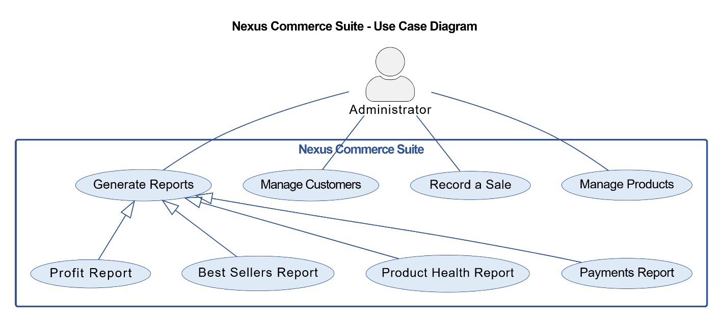

8.2 ER Diagram (Entity Relationship)
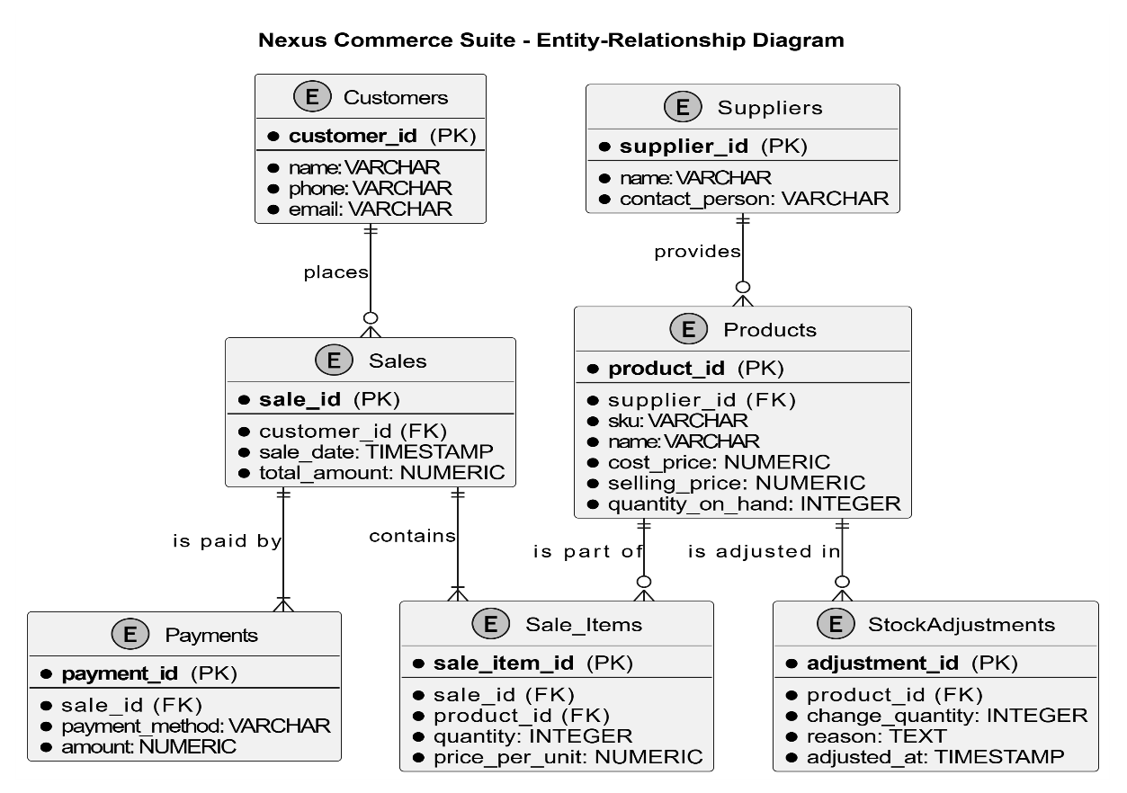

8.3 Class Diagram Analysis:
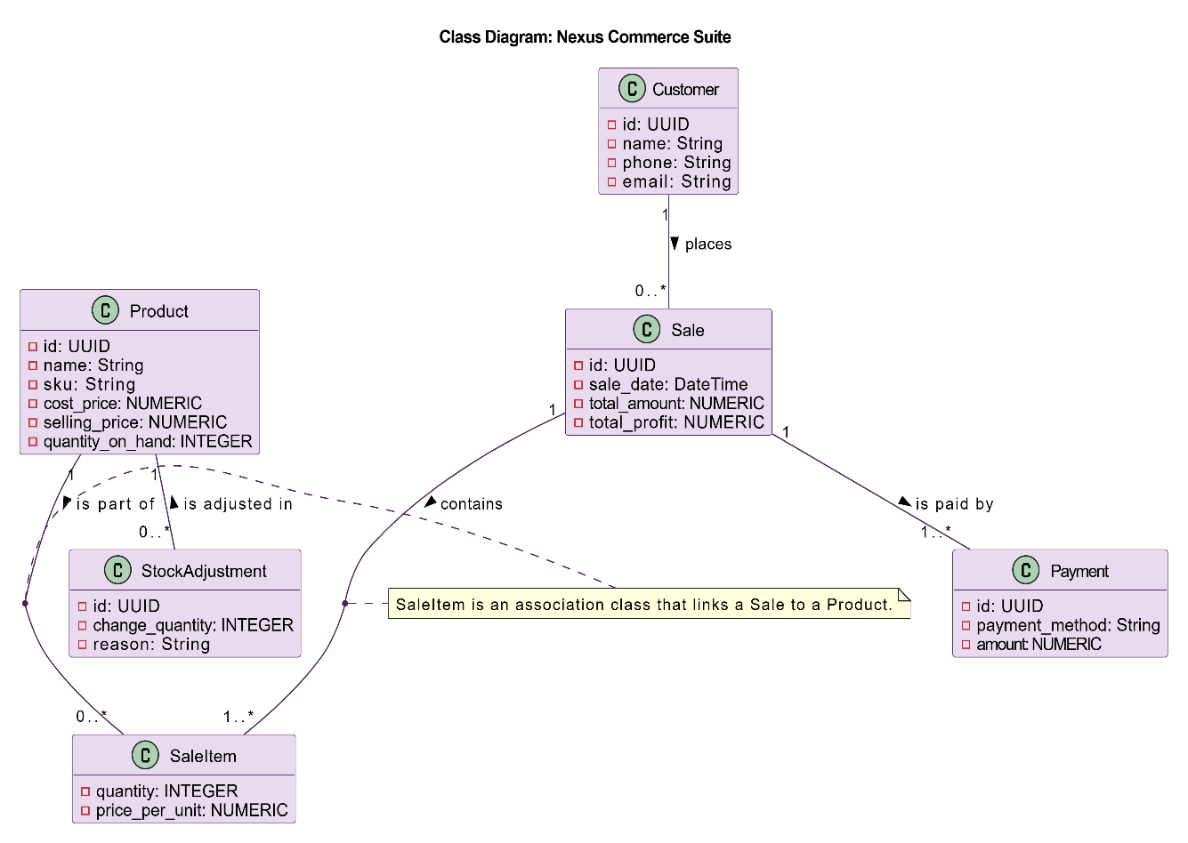

8.4 Sequence Diagram Analysis:
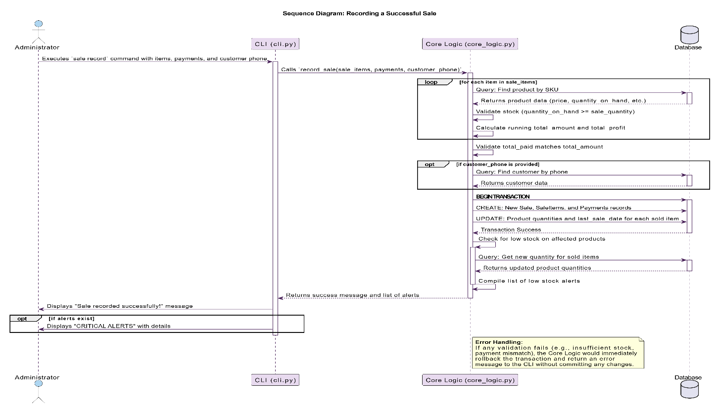
9. Database Design
- Customers
  - customer_id (Primary Key): A unique identifier for each customer.
  - name: The full name of the customer.
  - phone: The customer's phone number (used for lookups).
  - email: The customer's optional email address.
  - created_at: A timestamp of when the customer was added.
- Products
  - product_id (Primary Key): A unique identifier for each product.
  - sku: A user-defined, unique Stock Keeping Unit for easy product identification.
  - name: The name of the product.
  - cost_price: The price at which the product was purchased from the supplier.
  - selling_price: The price at which the product is sold to customers.
  - quantity_on_hand: The current, real-time stock level of the product.
  - last_sale_date: A timestamp of the last time this product was sold, used for health status reporting.
- Sales
  - sale_id (Primary Key): A unique identifier for each sales transaction.
  - customer_id (Foreign Key): Links the sale to a record in the Customers table.
  - sale_date: A timestamp of when the sale occurred.
  - total_amount: The total revenue generated from the sale.
  - total_profit: The total profit generated from the sale.
- Sale_Items
  - sale_item_id (Primary Key): A unique identifier for each line item within a sale.
  - sale_id (Foreign Key): Links the record to a specific sale in the Sales table.
  - product_id (Foreign Key): Links the record to a specific product in the Products table.
  - quantity: The number of units of the product sold in this transaction.
  - price_per_unit: The selling price of the product at the time of the sale.
- Payments
  - payment_id (Primary Key): A unique identifier for each payment.
  - sale_id (Foreign Key): Links the payment to a specific sale in the Sales table.
  - payment_method: The method of payment (e.g., "Cash", "UPI", "Card").
  - amount: The amount paid via this method.

10. System Architecture

10.1. Architectural Paradigm
The Nexus Commerce Suite follows a classic 3-Tier Layered Architecture. This model logically divides the application into distinct layers, each handling a specific aspect of the software's functionality. This separation ensures that a change in one layer (e.g., the user interface) has minimal to no impact on the others (e.g., the business rules or database).

10.2. High-Level Architecture Diagram

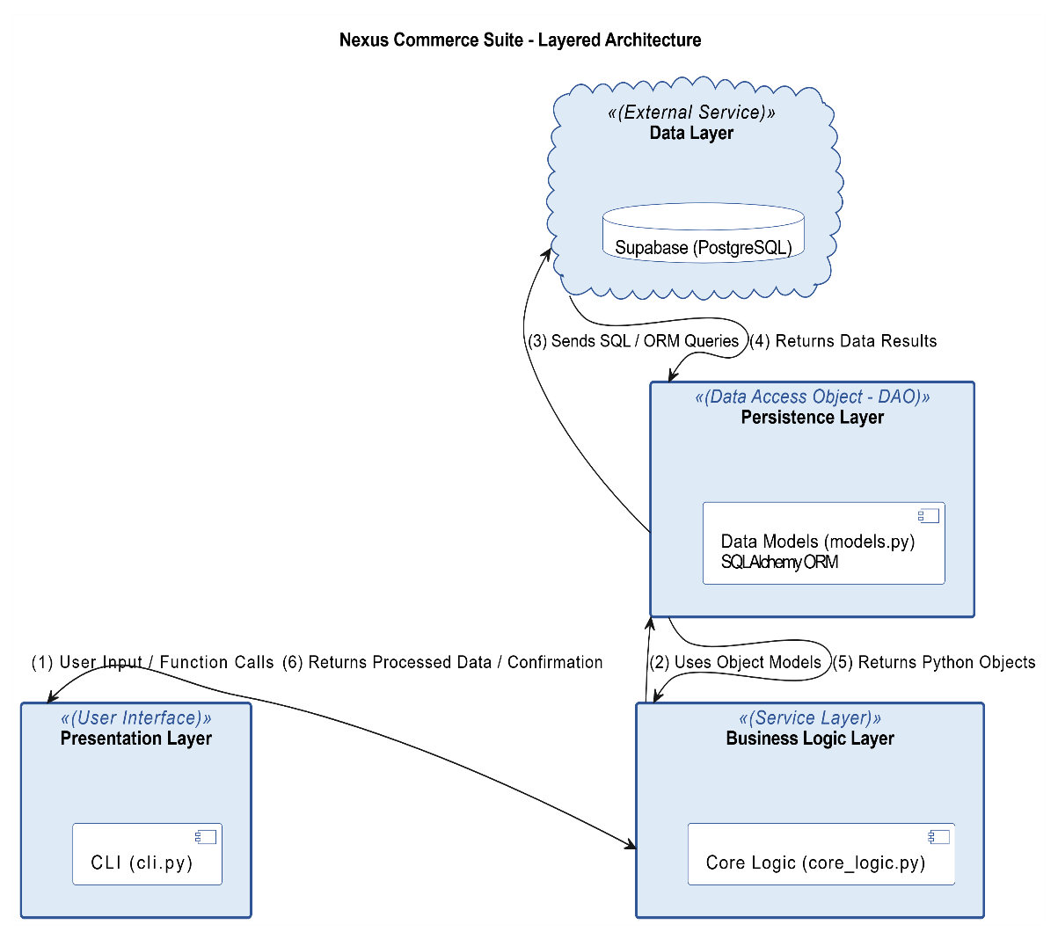

10.3. Layer-by-Layer Breakdown

- Presentation Layer (CLI - cli.py) This is the user interface. Its only job is to receive commands from the administrator and display formatted data. It contains no business rules and simply delegates all actions to the layer below.
- Business Logic Layer (Service - core_logic.py) This is the "brain" of the application. It contains all the business rules, validations (e.g., checking stock), and calculations (e.g., profit). It is completely independent of the user interface, making the system modular and reusable.
- Persistence Layer (Data Access - models.py) This layer acts as the bridge to the database. It translates the business logic's requests into database queries and ensures data integrity by managing atomic transactions. This guarantees that complex operations like a sale are an "all-or-nothing" event, preventing data corruption.
- Data Layer (Database - Supabase/PostgreSQL) This is the final storage layer where all business data is securely and persistently stored. It enforces data constraints and relies on the robust, managed infrastructure of Supabase for security, scalability, and backups.

11. Expected Outcomes

Upon successful completion, the Nexus Commerce Suite will deliver the following tangible results:
- An Efficient Management Tool: A fully functional, backend-driven CLI application that allows a business owner to manage their core operations without the need for manual records.
- Accurate, Real-Time Inventory: The system will provide an accurate, up-to-the-minute count of all product stock, with levels automatically updated after every sale.
- Centralized Customer & Sales Data: All sales will be accurately recorded and can be linked to a customer, providing a complete purchase history and a single source of truth for all transactions.
- Actionable Business Reports: The system will generate simple yet powerful reports for management, including profit/revenue analysis, best-seller lists, and product health statuses, enabling data-driven decision-making.

12. Future Enhancements

While the current scope delivers a complete and valuable tool, the system is designed on a foundation that allows for significant future enhancements, including:
- GUI / Web Application: Building a graphical user interface (web or desktop app) that interacts with the existing backend engine to provide a more visual and user-friendly experience.
- Multi-Store Support: Extending the database schema and logic to manage inventory, sales, and reporting across multiple physical store locations.
- Real-Time Dashboards: Developing a web-based dashboard that provides a live, visual representation of key performance indicators like sales per hour, current profit, and low-stock alerts.
- Integration with Payment Gateways: Connecting the system with payment gateways to automate the process of accepting digital payments.
- Purchase Order Management: Adding a full module to create, track, and manage purchase orders with suppliers to streamline the procurement process.

13. Conclusion

The Nexus Commerce Suite project successfully addresses the critical operational challenges faced by small and medium-sized businesses that rely on inefficient manual processes. By providing a centralized, backend-driven engine, it replaces the chaos of fragmented spreadsheets and ledgers with a single, reliable source of truth for inventory, sales, and customer data. The system not only automates routine tasks to save time and reduce errors but, more importantly, empowers the business owner with actionable, data-driven insights through its integrated reporting features.
Ultimately, this project delivers a powerful, scalable, and accessible tool that solves the defined problem effectively. It provides a solid foundation that not only optimizes current operations but also supports the future growth of the business, proving that sophisticated data management can be achieved through a simple and efficient command-line interface.

